NET731 — Advanced Networking
Week 3 Practical: Azure Virtual Machine Deployment

1. VM Deployment Summary
- VM Name: net731-vm
- Region: West Europe
- Size: B1ls
- Operating System: Ubuntu Server 22.04 LTS
- Resource Group: net731-rg
Authentication Method
SSH key authentication was selected instead of password-based authentication. This method is more secure because it reduces the risk of brute-force attacks and eliminates the need to transmit passwords over the network.

2. Network Summary
- Virtual Network: net731-vnet
- Address Space: 10.0.0.0/16
- Subnet Name: net731-subnet
- Subnet CIDR: 10.0.1.0/24
- Public IP Address: Static
- Network Security Group: net731-nsg
- Inbound Rule: Allow SSH (Port 22)
Explanation
A custom virtual network was created to ensure proper network segmentation instead of using default configurations. The /16 address space allows for future scalability, while the /24 subnet provides sufficient IP addresses for the virtual machine and potential expansion.
The Network Security Group was configured to allow only SSH traffic (port 22), ensuring secure remote access while blocking all other inbound traffic by default.

3. Auto-Shutdown Configuration
- Auto-Shutdown Status: Enabled
- Shutdown Time: 19:00
Justification
Auto-shutdown was configured to reduce unnecessary cloud costs by ensuring the virtual machine is not left running when not in use. This is important in both learning and production environments to promote efficient resource management.

4. VM Size Limitation Explanation
The required B1s virtual machine size was not available due to subscription quota limitations in the selected region. The Azure for Students subscription restricts the number of available vCPUs for certain VM families.
As a result, the closest available B-series size (B1ls) was selected to maintain cost efficiency while still meeting the practical requirements as closely as possible.

5. Reflection
One challenge encountered during this practical was the inability to select the required B1s virtual machine size due to quota limitations in the Azure subscription. This initially caused confusion, as the size was visible but not selectable.
To resolve this issue, alternative VM sizes were explored and the closest available option was selected. Additional research into Azure quotas helped clarify how resource limits affect deployment. This improved my understanding of how cloud resource constraints impact real-world deployments and how to adapt accordingly.

6. Screenshots
The following screenshots are included as evidence of the deployment and configuration:
- VM Overview page showing VM name, size and region
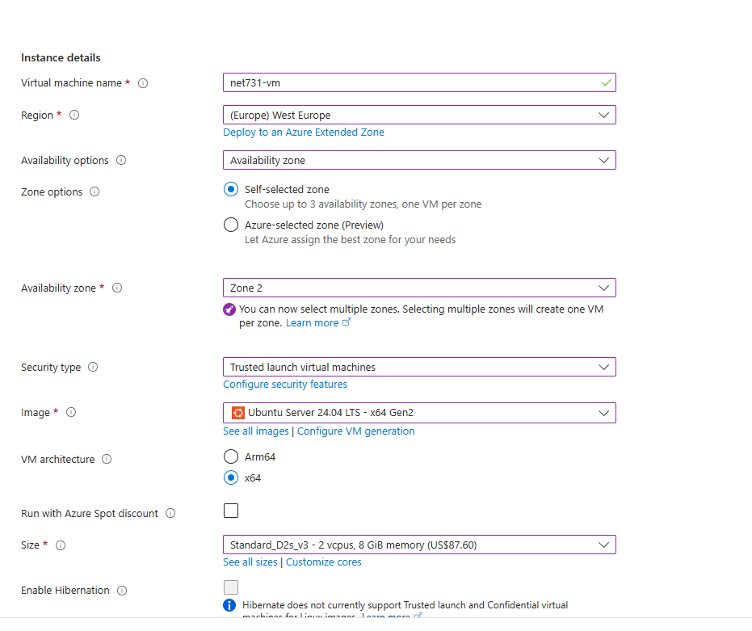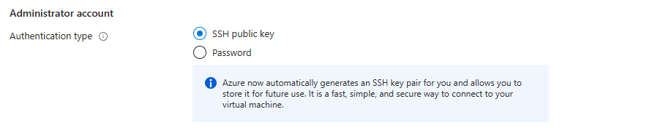
- Virtual Network and Subnet configuration with CIDR blocks visible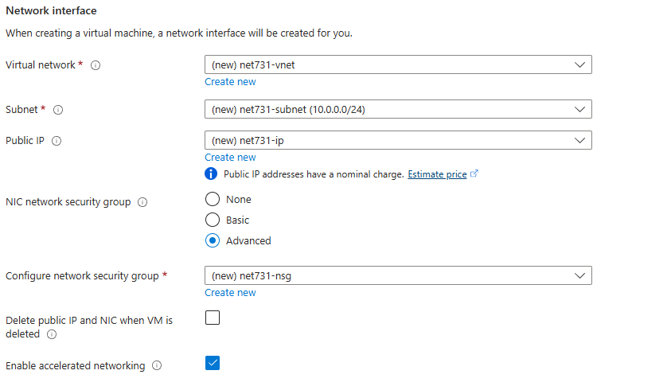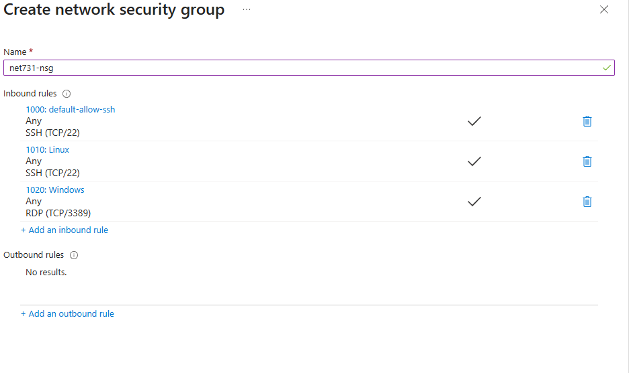

- Public IP address configuration showing Static assignment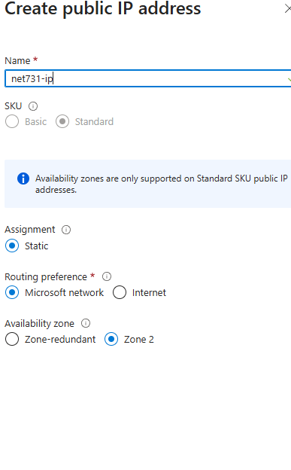
- Auto-shutdown configuration with the selected time